**Exploratory Analysis of Sales Performance of Key Activity Centres**

Introduction: This piece explores sales trend and performance of key account centres of a distribution chain for years 2017-2020.

Stores and Products, identified with IDs, are the key account centres.

There is a total of 909 products and 34 stores in the four-year period i.e. 2017 - 2020.

Business Case

I. What is the aggregate sales performance over the data period?

II. What are the top performing products and stores?

III. What are weakest products and stores?

These discoveries may impact budgeting and strategy to consolidate the top performers and look at ways of either improving the weakest products and stores or discontinuing them if they constitute unbearable drag on corporate bottom-line.

Yearly Sales

* The highest overall sale was in 2018.
* The lowest overall sale was in 2019.
* Good year, bad year, sale averages over $8million.

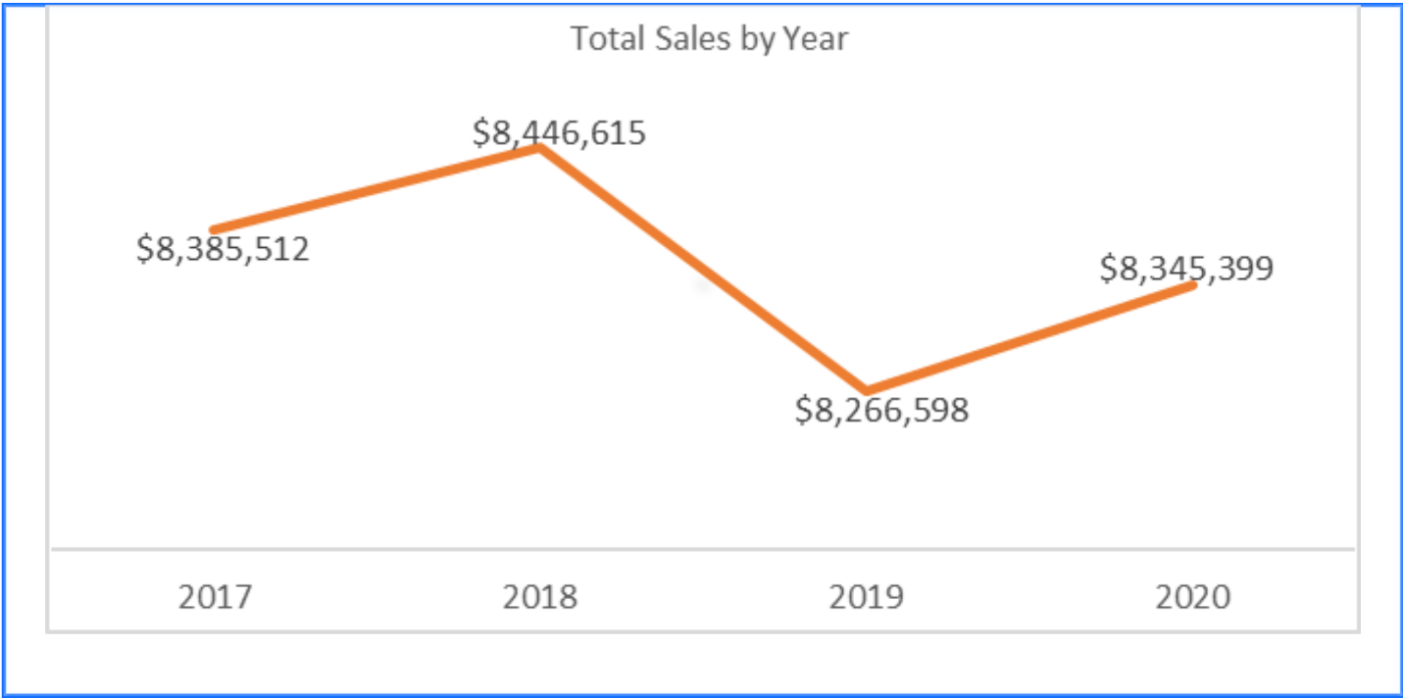

Top Five Products by Gross Sales from 2017 through 2020.

* Highest selling products are star products.

Top Five Stores by Gross Sales from 2017 through 2020

* Star stores are those with highest overall sales.
* They account for about 15% of total sales

Bottom Five Products by Gross Sales from 2017 through 2020

* The lowest selling products are the weakest products.

Bottom Five Stores by Gross Sales from 2017 through 2020

* Weakest stores by sales
* Account for about 14% of total sales

